Software Engineering Assignment

**MODULE: 1**

**SE – Overview of IT Industry**

**Q-1. What is software? What is software engineering?**

**ans** - Software engineering has two parts: software and engineering.

* Software is a collection of codes, documents, and triggers that does a specific job and fills a specific requirement.
* Engineering is the development of products using best practices, principles, and methods.
* Software engineering is the application of a systematic, disciplined and quantifiable approach to the development, operation and maintenance of software.

**Q-2. Explain types of software.**

**ans** - Software is the “collection of computer programs, procedures, rules, associated documents and concerned data with the operation of data processing system”.

● Software Application Domain types:

1. System Software
2. Application Software
3. Embedded software
4. Web application
5. Artificial intelligence (AI) software

● **System Software** **:** It is responsible for controlling, integrating the hardware components of a system so the software and the users can work with them. Example: Operating System, Device drivers.

● **Application Software** **:** It is used to accomplish some specific task. It should be collection of small programs. Example: Microsoft Word, Excel etc.

● **Embedded Software** **:** Embedded software is a software that is embedded in hardware or non-PC devices. It is written specifically for the particular hardware that it runs on. It usually has processing and memory constraints. Examples of embedded software: factory robots, some calculators and dedicated GPS devices.

● **Web Application** **:** A web-application is an application program that is usually stored on a remote server, and users can access it through the use of Software known as web-browser. It is a type of computer program that usually runs with the help of a web browser and also uses many web technologies to perform various tasks on the internet. Example: tools like Google docs, CMS .

● **Artificial intelligence Software** **:** Artificial intelligence is the simulation of human intelligence processes by machines, especially computer systems. Specific applications of AI include expert systems, natural language processing, speech recognition and machine vision. Artificial Intelligence (AI) Software is a computer program which mimics human behavior by learning various data patterns and insights. Top features of AI software include Machine Learning, Speech & Voice Recognition, Virtual Assistant etc

**Q-3. What is SDLC? Explain each phase of SDLC.**

**ans** - SDLC is focused on software development, while PDLC is focused on product development. SDLC consists of various phases, such as planning, design, coding, testing, and deployment, while PDLC includes additional phases, such as market research, product planning, and marketing.

**1.To ensure that the software is of high quality:**The SDLC includes testing and quality assurance phases, which help to ensure that the software is free of bugs and that it meets the requirements.

**2.**[**To manage risks and costs:**](https://www.geeksforgeeks.org/software-risk-analysis/)The SDLC helps organizations to identify and manage risks early in the development process, which can help to reduce costs and minimize the impact of any issues that do arise.

**3.To improve communication and collaboration:**The SDLC helps to ensure that all stakeholders, including customers, end-users, and developers, are involved in the development process and that their needs are taken into account.

**4.To improve efficiency and productivity:**The SDLC helps organizations to optimize the use of resources and to streamline the development process, which can improve efficiency and productivity.

**5.To increase the likelihood of a successful project outcome:** Following a well-defined SDLC process can greatly increase the chances of success of the project, as the process guides the team towards the goal in a systematic and efficient way.

Overall, the **SDLC is a valuable tool** for organizations to use when developing software applications, as it helps**to ensure that the final product is of high quality, meets the requirements**, and is delivered on time and within budget.

**SDLC typically includes the following phases:**

**1.**[**Requirements gathering and analysis:**](https://www.geeksforgeeks.org/requirements-gathering-introduction-processes-benefits-and-tools/)This phase involves gathering information about the software requirements from stakeholders, such as customers, end-users, and business analysts.

**2. Design:** In this phase, the software design is created, which includes the overall architecture of the software, data structures, and interfaces. It has two steps:

* **High-level design (HLD):** It gives the architecture of software products.
* **Low-level design (LLD):** It describes how each and every feature in the product should work and every component.

**3. Implementation or coding:** The design is then implemented in code, usually in several iterations, and this phase is also called as Development.

things you need to know about this phase:

* This is the longest phase in SDLC model.
* This phase consists of Front end + Middleware + Back-end.
* **In front-end:**Development of coding is done even SEO settings are done.
* **In Middleware:** They connect both the front end and back end.
* **In the back-end:** A database is created.

**4. Testing:**The software is thoroughly tested to ensure that it meets the requirements and works correctly.

**5. Deployment:** After successful testing, The software is deployed to a production environment and made available to end-users.

**6. Maintenance:**This phase includes ongoing support, bug fixes, and updates to the software.

**Q-4. What is DFD? Create a DFD diagram on Flipkart.**

**ans** - A data flow diagram (DFD) is a graphical or visual representation using a standardized set of symbols and notations to describe a business's operations through data movement. They are often elements of a formal methodology such as Structured Systems Analysis and Design Method (SSADM).

**admin side DFD:**

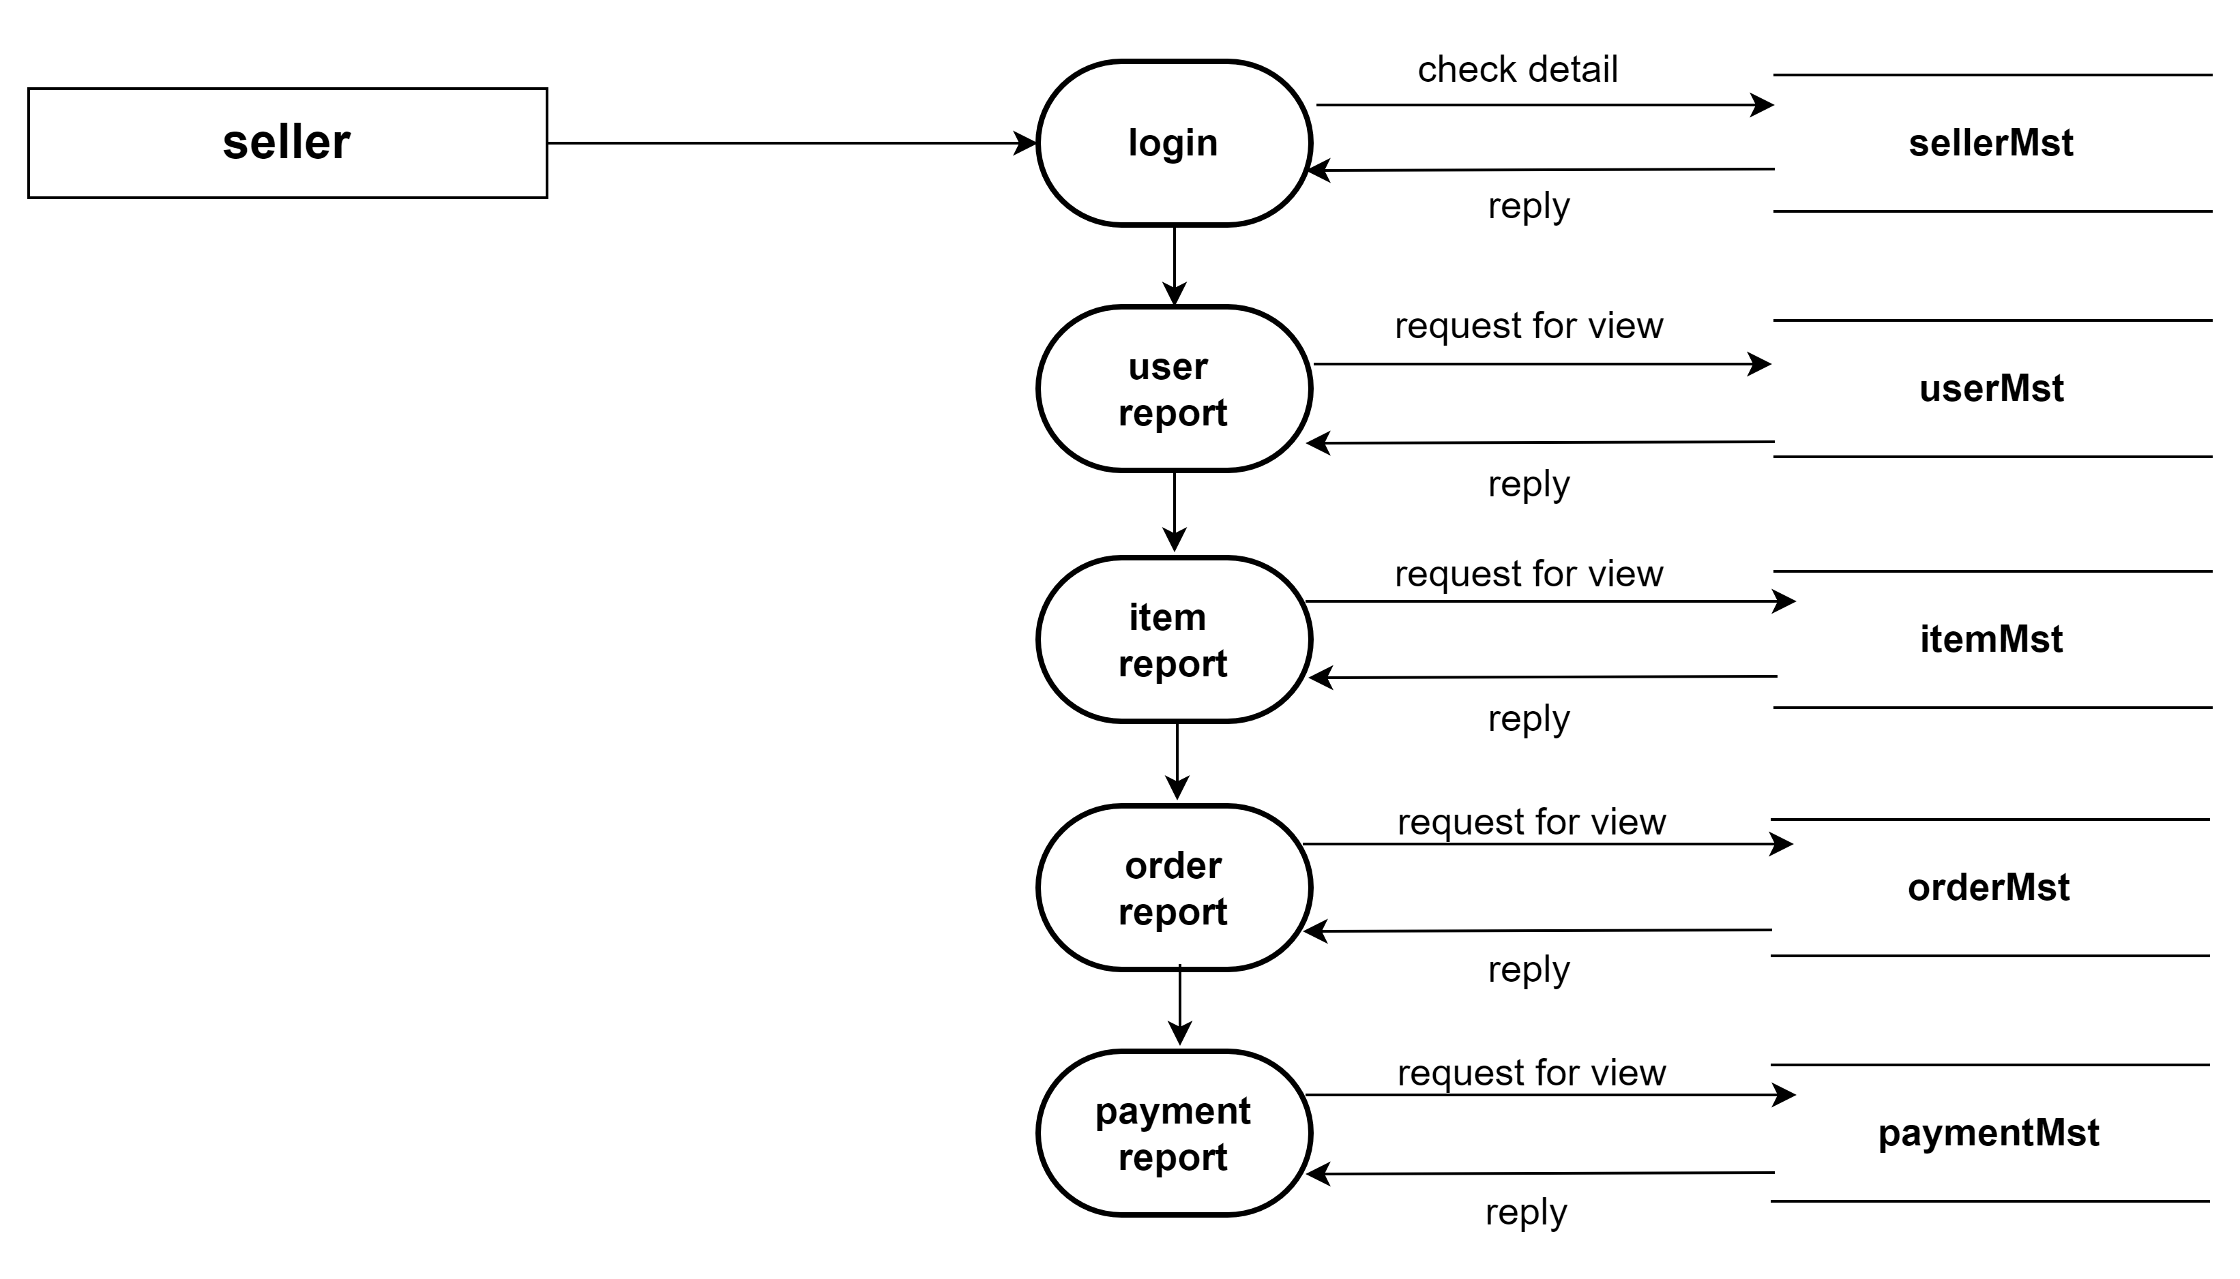

**User side DFD:**

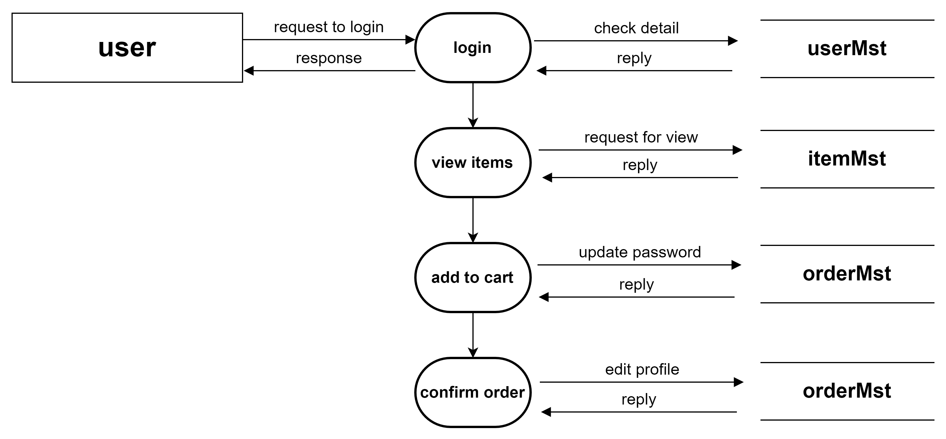

**Q-5. What is Flow chart? Create a flowchart to make addition of two numbers.**

**Ans-** A flowchart is a picture of the separate steps of a process in sequential order. It is a generic tool that can be adapted for a wide variety of purposes, and can be used to describe various processes, such as a manufacturing process, an administrative or service process, or a project plan.

**Flowchart for addition of two numbers----------**

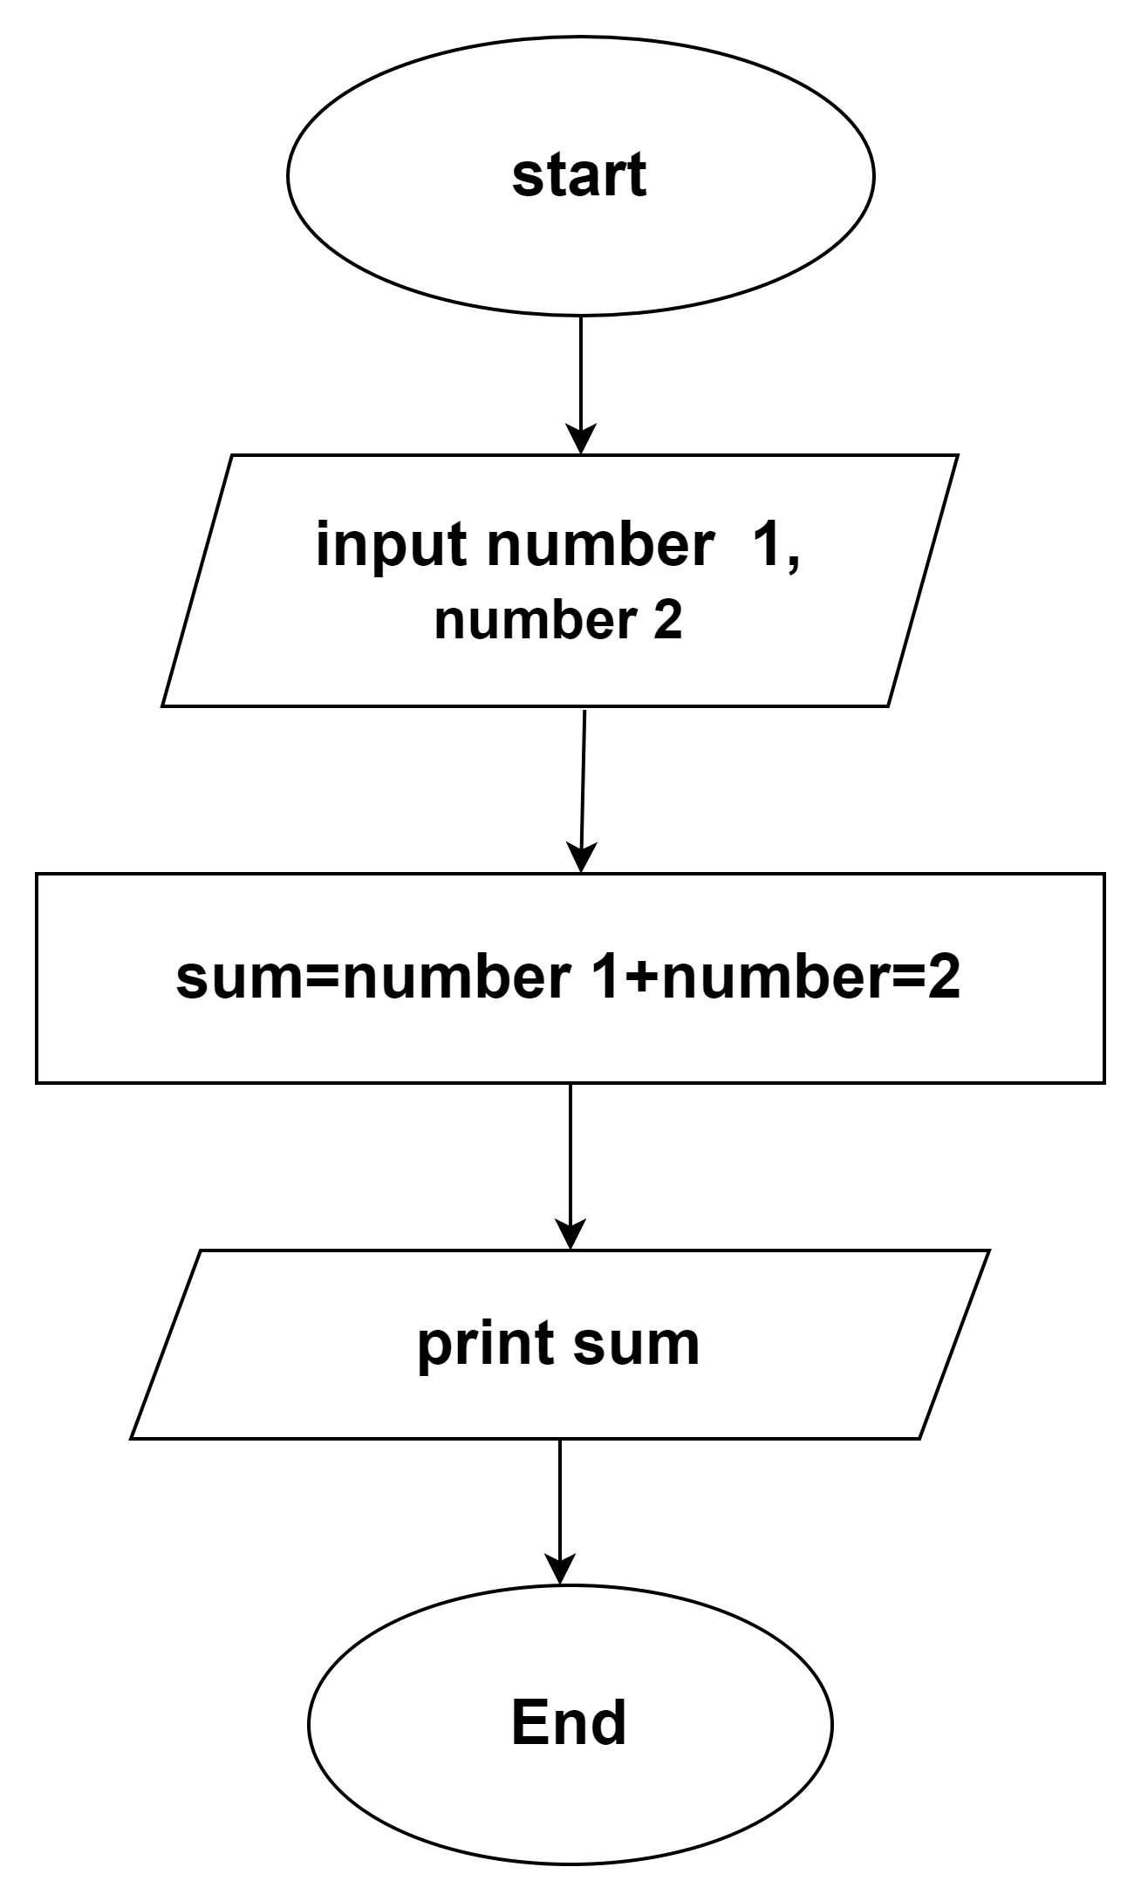

**Q-6. What is Use case Diagram? Create a use-case on bill payment on paytm.**

* A Use Case Diagram is a vital tool in system design, it provides a visual representation of how users interact with a system. It serves as a blueprint for understanding the functional requirements of a system from a user’s perspective, aiding in the communication between stakeholders and guiding the development process.
* A use case name is often short and you can use the description to elaborate more, often using paragraph form.
* **For example: An e-commerce user selects an item they want to buy, so they place it in their online cart intending to place the order and pay electronically.**

